d-

clc

clear

close all

t = 0:0.1:5;

for j = 1:length(t)

i(j) = (50/3)-(50/3\*exp(-3\*t(j)));

end

2

plot(t, i)

title('Time vs Current')

xlabel('t (s)')

ylabel('i (A)')

Output:

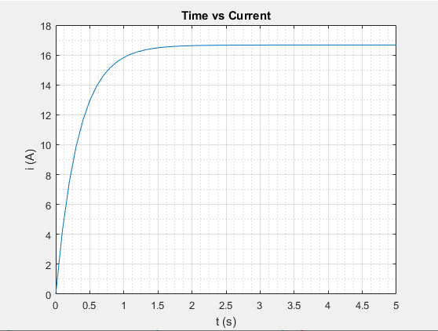

d)

t = 0:0.1:10;

for j = 1:length(t)

current(j) = ((50/3)-(50/3)\*(exp(-3\*t(j))));

end

plot(t, current)

title('Time vs Current')

xlabel('time (s)')

ylabel('current (A)')

grid minor

grid on

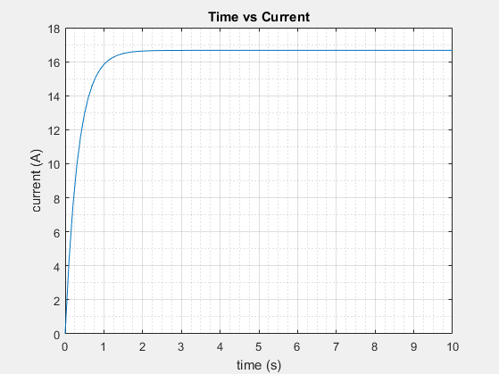

d-

time = 0:0.1:10;

for k = 1:length(time)

A(k) = ((50/3)-(50/3)\*(exp(-3\*time(k))));

end

plot(time, A)

grid minor

grid on

title('Time vs Current')

xlabel('T (sec)')

ylabel('I (Amps)')

